SIMATS ENGINEERING
ASSESSMENT TOOL 3 – Assignment 2

COURSE NAME: STATISTICS WITH R PROGRAMMING COURSE CODE: ITA04

COURSE OUTCOME COVERED
CO3: Construct and manipulate data frames using reshaping, merging, and file I/O
operations in R to prepare structured datasets for analysis.. (BL3, BL5)
Assessment Tool Weightage: 20%

QUESTIONS: 5 Total Marks: 100

Annexure
Assignment 2

Code of Conduct:
I Pravin R ( 192421292) certify that this submission is my original work and that I have adhered to the guidelines specified for this assessment. I understand that any violation of academic integrity rules will result in disciplinary action.
Signature of the student:


Assignment 2:
- Generate 5 Questions for your Capstone Project module
- Apply the formulae and use the relevant graph to visualize it
- Upload the file in GitHub link
- Save the 5 Questions and GitHub link in the Excell sheet

ITA0408 - Statistics with R Programming
Name : Pravin R
Reg. No : 192421292
Title - CareerIQ: Student Placement and Career Recommendation
Module 1 - Data Processing & Placement Prediction
Dataset Used : https://www.kaggle.com/datasets/sahilislam007/college-student-placement-factors-dataset
1) What is the distribution of CGPA among students?
Test: Descriptive Statistics
Formula: Mean CGPA
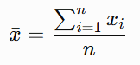
Formula Explanation:
- xˉ= Average CGPA
- $x_{i}$= CGPA of each student
- $n$= Total number of students
- $\sum{x_{i}}$= Sum of all students' CGPA values
Graph: Histogram
Code:
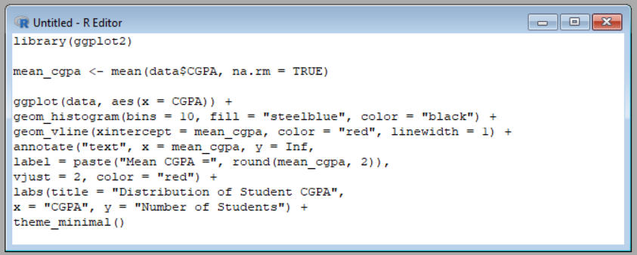
Output graph:

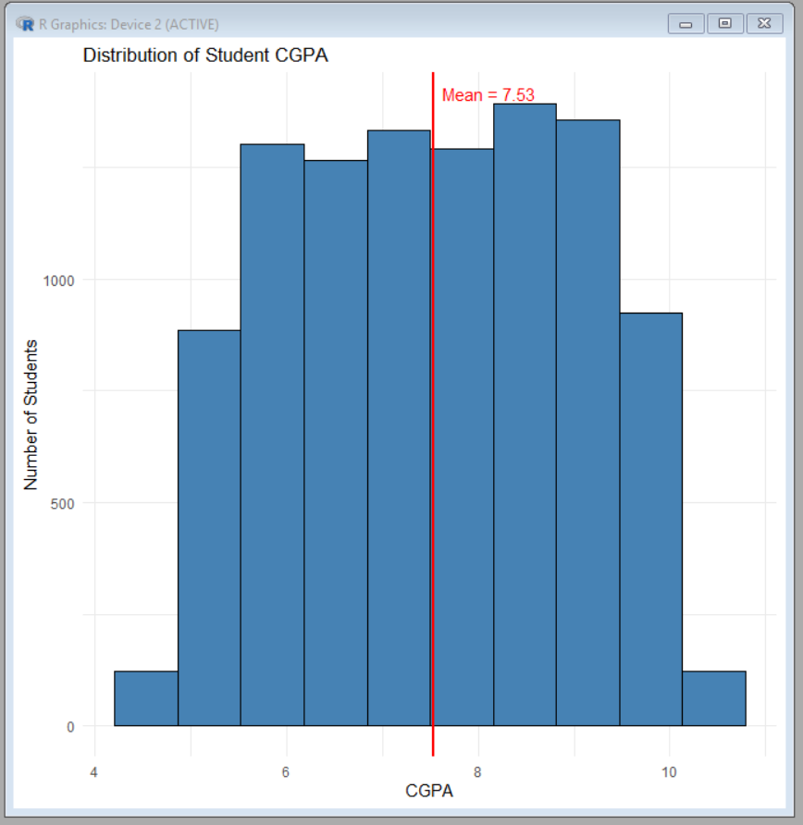

2) What is the average number of projects completed by students?
Test: Descriptive Statistics
Formula: Arithmetic Mean
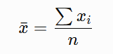
Formula Explanation:
- xˉ= Average number of projects completed
- $x_{i}$= Projects completed by each student
- $n$= Total number of students
- $\sum{x_{i}}$= Total number of projects completed by all students
Graph: Bar Chart
Code:
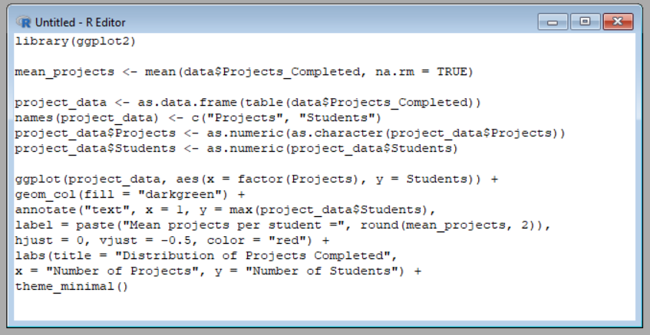
Output Graph:
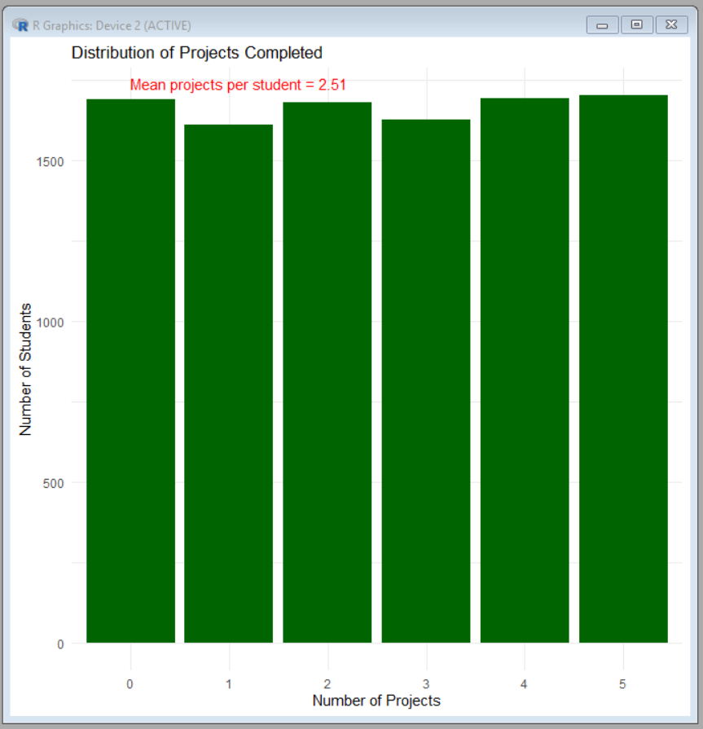
3) Is there a significant difference in the average CGPA of placed and non-placed students?
Test: Independent Samples t-test
Formula:
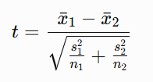
Formula Explanation:
- t= Calculated t-statistic
- ${\overline{x}}_{1}$= Mean CGPA of placed students
- ${\overline{x}}_{2}$= Mean CGPA of non-placed students
- $s_{1},s_{2}$= Standard deviations of the two groups
- $n_{1},n_{2}$= Number of students in the two groups
Graph: Box Plot
Code:
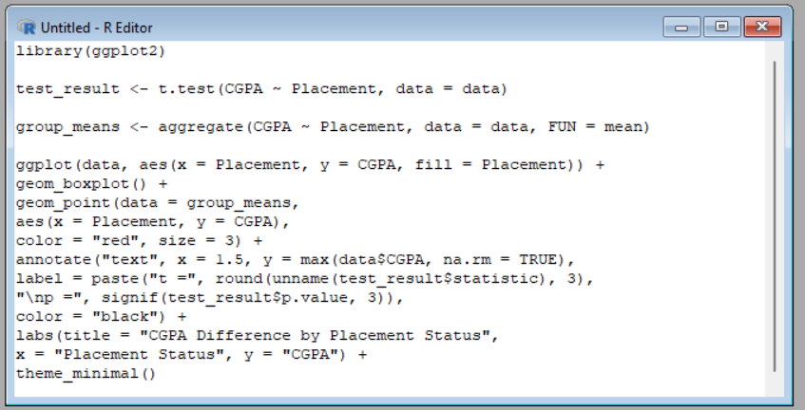

Output Graph:
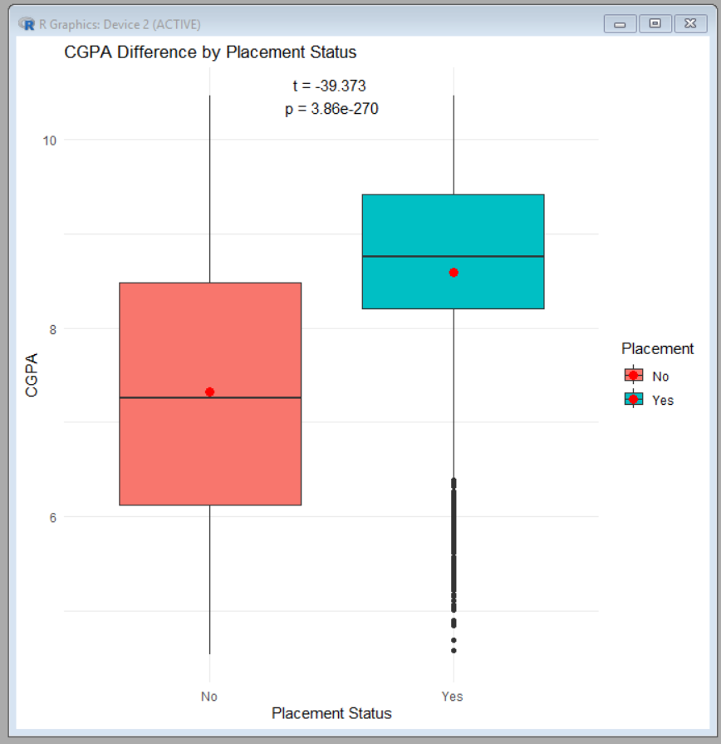

4) Is there an association between internship experience and placement status?
Test: Chi-square Test of Independence
Formula:
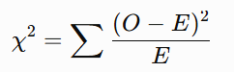
Formula Explanation
- $χ^{2}$= Chi-square statistic
- $O$= Observed frequency in a category
- $E$= Expected frequency if the two variables were independent
- = Sum across all table cells
Graph: Grouped Bar Chart
Code:
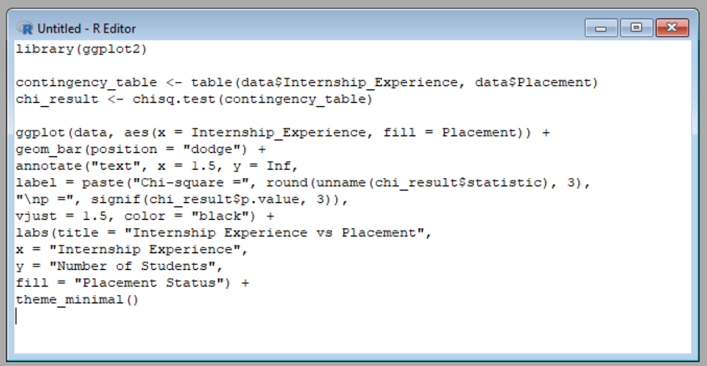

Output Graph:
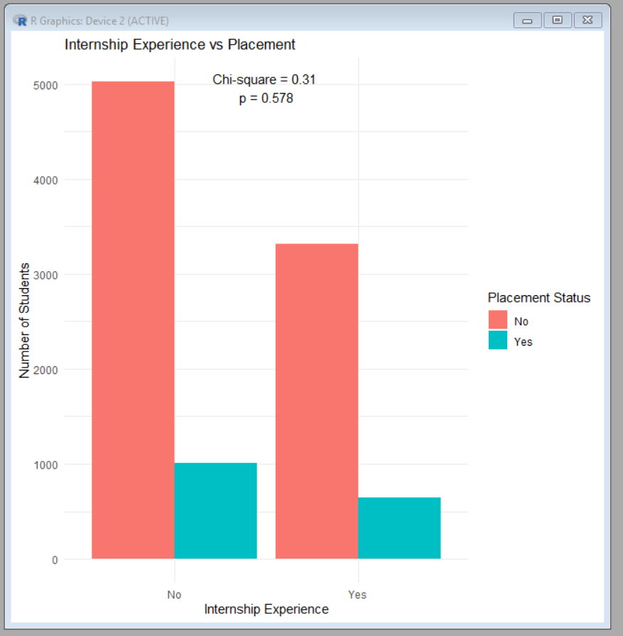

5) Is there a significant difference in average CGPA among students with different academic performance scores?
Test: One-Way Analysis of Variance (ANOVA)
Formula:
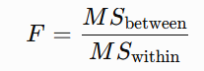
Where:
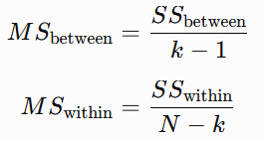
Formula Explanation:
- $F$= ANOVA F-statistic
- $MS_{\text{between}}$= Mean square variation between groups
- $MS_{\text{within}}$= Mean square variation within groups
- $SS_{\text{between}}$= Sum of squares between group means
- $SS_{\text{within}}$= Sum of squares within groups
- $k$= Number of academic performance groups
- $N$= Total number of students
Graph: Box Plot
Code:
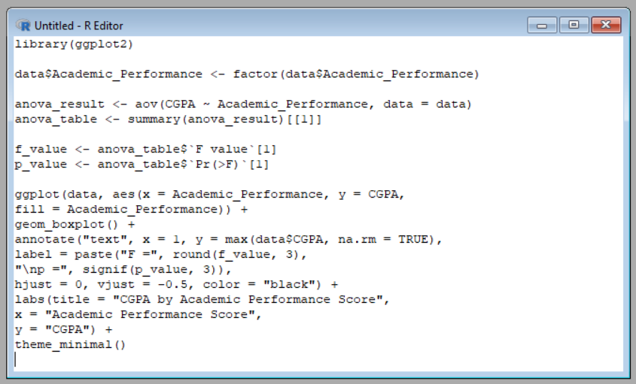

Output Graph:
